A Novel Method For Handwritten Digit Recognition System

# ABSTRACT

Handwritten digit recognition has recently been of very interest among the researchers because of the evolution of various Machine Learning, Deep Learning and Computer Vision algorithms. This work involves in studying and to compare the results of some of the most widely used Machine Learning Algorithmslike CNN- convolution neural and with deep learning algorithm like multilayer CNN using Keras with Theano and TensorFlow. MNIST is a dataset which is widely used for handwritten digitrecognition. The dataset consists of 60,000 training images and 10,000 test images. The artificial neural networks can all most mimic the human brain and are a key ingredient in image processing field. For example, Convolution Neural networks with back propagation for image processing. The applications where these handwritten digits recognition can be used are Banking sector where it can be used to maintain the security pin numbers, it can be also used for blind peoples by using sound output.[1]

***Keywords****: Pattern recognition, neural network, handwritten characters*

## INTRODUCTION

Handwriting recognition (HWR), also known as handwritten text recognition (HTR), is the ability of a computer to receive and interpret intelligible handwritten input from sources such as paper documents, photographs, touch-screens and other devices. Handwritten digit recognition is the ability of a computer to recognize the human handwritten digits from different sources like images, papers, touch screens, etc, and classify them into 10 predefined classes (0-9). One of the many computer-related problems that are sought and researched is how images can be recognized and classified. Image recognition is an important process for image processing. In image recognition, the angle of view, light conditions, and whether the captured image is clear or not will affect the process of recognizing the image. Handwriting recognition is one of the most sought after and studied issues, since handwriting can help

humans do some work such as post-exposure, bank check analysis, and handwritten processing on forms.

The recognition of images for handwriting is more challenging because each person must have a different handwriting form. In addition to writing handwriting is not always straight sometimes there is a sloping up and there is a downward slant, so handwriting will be more difficult to detect than computer writing that already has a definite form. Handwriting detection definitely has more factors that will influence the successful recognition of a handwriting.

Because a misinterpretation will be more handwriting than computer writing that is certain to have a fixed form depending on the type. For handwriting recognition, there are several methods that can be used that will be discussed in the next section.[4]

## LITERATURE REVIEW

As we know there is no computer which can beat the level of the human brain. So due to these inefficiencies in computers we use artificial neural networks to make them somehow efficient like humans. Human brain easily processes and analyses images. Brain automatically identifies and recognizes the elements and features of images.

Image processing is a field which deals with enabling machines to do such tasks that our brain can do with images. Nowadays we see that technology is increasing repeatedly and many options are available to perform Handwritten digit recognition. But CNN plays a very crucial role in many image processing applications. CNN is used for detection of data loss (fault) and accuracy of the application.

In this study, we have investigated the applications of deep learning with other techniques such as CNN using tensorFlow, keras, openCV. These algorithms are used widely by researchers as experiments for theories of machine learning. Many researchers are using this technique other than machine learning algorithms such as SVM, KNN, and RFC etc., they prefer to use CNN because it gives high accuracy in image classification, video analysis.[3]

## 2.1 HANDWRITTEN CHARACTER RECOGNITION IN PATTERN RECOGNITION

Linear Classification is a useful method to recognize handwritten characters. The background basis of Artificial Neural Network (ANN) can be implemented as a classification function. Linear Classification works very similar to Artificial Neural Network because the

mapping of the ANN cell or one layer of the ANN cell is equivalent to the linear discrimination function. Therefore, if the ANN is a two-layer network, which is consisting of an input and an output layer, it can act as a linear classifier.[1]

## ARCHITECTURE - HANDWRITTEN RECOGNITION SYSTEM

The first layer of the architecture is the User layer. User layer will comprise of the people who interacts with the app and for the required results. The next three layers is the frontend architecture of the application. The application will be developed using Bootstrap which is the open-source platform for HTML, CSS and JavaScript. The application is deployed in the localhost which is shown on the browser.

Through the app, the user will be able to upload pictures of the handwritten digits and convert it into the digitalized form. The one in between the database and view layer is the business layer which is the logical calculations on the basis of the request from the client side. It also has the service interface.

The backend layer consists of two datasets: Training Data and Test Data. The MNIST database has been used for that which is already divided into training set of 60,000 examples and test of 10,000 examples. The training algorithm used is Convolution Neural Network. This will prepare the trained model which will be used to classify the digits present in the test data. Thus, we can classify the digits present in the images as: Class 0,1,2,3,4,5,6,7,8,9.[2]

## PROPOSED IDEA

There are many different types of recognitions in the modern time, which can really solve complex problems in the real world today. Examples of recognitions are: face recognition, shape recognition, handwritten character recognition, such as handwritten Chinese character recognition and handwritten digit recognition.[1]

The MNIST dataset contains **60,000 training cases and 10,000 test cases of handwritten digits (0 to 9)**. Each digit is normalized and centered in a gray-scale (0 - 255) image with size 28 × 28. Each image consists of 784 pixels that represent the features of the digits.

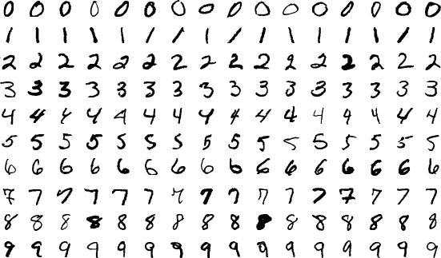

Fig 1 – Sample Dataset

## Architecture

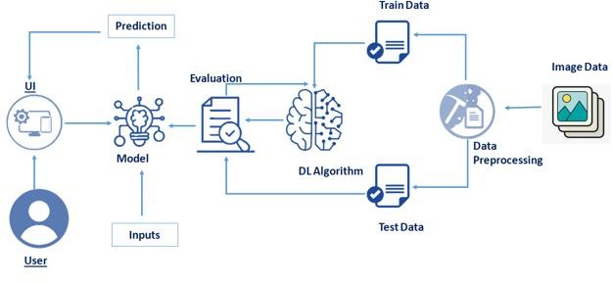

* 1. **Features of the system**
     + Electronic data storage
     + More organized files
     + Easier data retrieval
     + Historical preservation
     + Can be easier form of writing
     + Verification methods.

## Challenges of the System

* + - Recognition is not 100% accurate.
    - Converted documents will need to be checked.
    - Dirty or damaged documents are difficult to read.

# Conclusion

An implementation of Handwritten Digit Recognition using Deep Learning has been implemented in this paper. Additionally, some of the most widely used Machine Learning algorithms i.e., CNN using TensorFlow have been trained and tested on the same data to draw a comparison as to why we require deep learning methods in critical applications like Handwritten Digit Recognition. In this study, Deep Learning techniques seems to have better accuracy. Using the Convolutional Neural Network with Keras and Theano as backend, I am able to get an accuracy of 95.72%. Every tool has its own complexity and accuracy. Although, we see that the complexity of the code and the process is bit more as compared to normal Machine Learning algorithms but looking at the accuracy achieved, it can be said that it is worth it. Also, the current implementation is done only using the CPU and the planned to use more computing power using IBM cloud or google colab. Thus, we consolidated on classifying a given handwritten digit image as the required digit using three different algorithms and consequently testing its accuracy. In future we are planning to further explore the topic to recognize people’s handwriting in real-time. [2]

# Reference

1. Mr.Malothu Nagu, Mr.N.Vijaya Shankar, Mrs.K.Annapurana, "A Novel Method for Handwritten Digit Recognition with Neural Networks ", 2011.
2. Mrs.M.Rohini, Dr.D.Surendran, "A Novel Method For Hand Writting Digit Recognition Using Deep Learning",2019.
3. Mr.Shubham Mendapara, Mr.krish Pabani, Mrs.Yash Paneliya, "Handwritten Digit Recognition System", September-october 2021.
4. Mrs.Salma shofia Rosyda, Mr.Tito Waluyo Purboyo, "A Review of Various Handwriting Recognition Methods",2018.